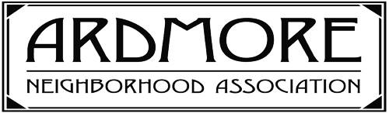
Ardmore ArtWalk 2020
Saturday, October 10, 2020, 1 to 5 p.m.*

Name of artist or crafts person:

Ardmore street address:

Preferred phone number:

Email address:

Brief description of your art or craft:

For an enrollment fee of $35, participants will receive an annual membership in ANA, a yard sign for the day of ArtWalk 2020, and your location and art category will appear on a map of Ardmore on the ANA website. Also, artists will be included on the Ardmore Creatives page of the ANA website for one full year. Your craft or art form will be listed along with contact information, including a direct link. For current members of ANA, the total fee is $25.
Deadline for submitting application and payment (payable to ANA): September 10th
Please mail to: ANA, PO Box 5834, Winston Salem, NC 27113

Sponsored by the Ardmore Neighborhood Association (ANA)
https://ardmore.ws/

*Rain date is Saturday. October 17th

